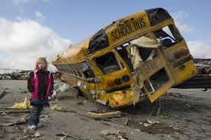

CISM Refresher Class
Critical Incident Stress Management

“Group Crisis Intervention & Assisting Individuals in Crisis”

Friday October 20th 2023 8:30-4:30
Hotel-Dieu Grace Healthcare
1453 Prince Rd, Windsor Ont N9C 3Z4
Chrysler Room, Dr Y. Emara Building
Facilitated by Brian Bennett
ICISF approved instructor, Canadian Ski Patrol National CISM Coordinator

Why Should I Attend?
Has it been a while since you took your initial training, haven’t been to as many interventions as you would like, looking to develop your skills in supporting your peers, or looking to feel more comfortable while helping others in their time of need?
Through this 8hr refresher course we will review the basics, have a chance to practice scenarios, and learn to provide better and more consistent care to our peers.

Content includes:
This 8hr session reviews content that is part of the Group and Individual courses including:

- Signs and Symptoms of distress
- Communication
- Healthy coping mechanisms
- SAFER-R individual interventions
- RITS

- CMB Crisis Management Briefing
- Defusing’s
- Debriefing’s
- Strategic planning
- Keeping yourself healthy

Workshop Registration:
This refresher course is for all those with previous training in Critical Incident Stress Management.
Cost is $100 per person. To register for the course please contact Francine Stadler, Francine.Stadler@hdgh.org T:519-257-5111 x74112. If you know someone that might be interested in the full 3 day training program, one will be offered Oct 17-19th at the same location. Contact Francine or cismtraining.ca for details.

